Do Not Compare: Why 5-Year Migration Estimates from the Annual Social and Economic Supplement of the Current Population Survey Are Not Comparable with 5-Year Multiyear Migration Estimates from the American Community Survey

David Ihrke
U.S. Census Bureau

SEHSD Working Paper Number 2017-02

Introduction

The American Community Survey (ACS) and the Annual Social and Economic Supplement (ASEC) of the Current Population Survey (CPS) both collect data on geographical mobility. In some cases, migration estimates are comparable. For instance, annual migration rates between the ACS and ASEC. Even though mover rates have historically been higher in the ACS than ASEC, they are comparable., In the case of 5-year ASEC migration data and 5-year multiyear ACS estimates, the estimates are not comparable under any circumstance. After describing the relevant history behind each set of estimates, this paper explains why they are not comparable, which one to use, and when.

History: Five-year CPS/ASEC Migration

Migration questions have been asked on the CPS since 1948, usually with a 1-year reference period. Between 1971 and 1980, the reference period of the migration questions changed. Instead of asking where respondents lived 1 year ago, the questions asked where they lived in 1970 for people surveyed between 1971 through 1975 and 1975 for people surveyed between 1976 and 1980. This approach created the first 5-year migration estimates for the CPS in 1975. The fact that it fell on the year 1975, midway between the 1970 and 1980 Censuses, meant it could act as a midway point for Census 5-year migration estimates. Five-year questions were later added onto the CPS in 1985, 1995, and 2005. The Census long form, the place where 5-year migration questions were historically asked, was discontinued after 2000, meaning no 5-year migration data would be collected for 2010. To alleviate this situation, the 5-year migration questions were added to the 2010 ASEC. This decision continued the trend of uninterrupted 5-year data going back to 1975. More recently, the 5-year questions were asked on the 2015 ASEC. At the time of this writing, there are plans to continue to add 5-year migration questions to ASEC on years ending in “0” and “5”.

History: Multiyear ACS Migration

The ACS began with test and demonstration phases throughout the late 1990s and early 2000s. Full implementation began in 2005, which was limited to household residents. Group quarter (GQ) residents were added in 2006. During this time, only geographies with populations of 65,000 or more received estimates from 1-year ACS data. Geographies with populations fewer than 65,000 were forced to rely on older, dated decennial census data or estimates from the population estimates program. The 3-year multiyear ACS estimates, first released in 2008 using 2005 through 2007 ACS data, offered a more up-to-date alternative for geographies with populations of 20,000 or more. Five-year multiyear estimates using 2005 through 2009 ACS data were first released in 2010. These estimates were available for all geographies, regardless of their population size.

What are multiyear ACS estimates and how were they created?

Before continuing, it is important to understand what multiyear ACS estimates are and are not. Multiyear estimates are several years of ACS data combined, or “pooled,” together and reprocessed to create new sets of period estimates., Survey questions remain the same for single-year and multiyear estimates. In the case of migration, the reference period of a move is still one year. However, the interpretation of estimates changes because multiyear estimates cover longer survey periods than single-year estimates. For example, according to the 2010 1-year ACS, 9.4 percent of the population 1 year and over moved within the same county between 2009 and 2010. In this example, all of the respondents completed the ACS in 2010. This is not the case for the multiyear estimates. Using the 2006-2010 5-year multiyear estimates, 9.4 percent moved within the same county within a 1-year period. Some of these respondents completed the ACS in 2006 while others completed it in 2010. This is demonstrated visually in Figure 1, which displays the survey and reference period for the 2006 through 2010 1-year ACS, the 2006-2010 5-year ACS, and the 2010 5-year ASEC. For this example, the correct interpretation is that 9.4 percent moved within the same county over a 1-year period between the years of 2006 and 2010.

Why are the 5-year ASEC migration estimates not comparable with the 5-year multiyear ACS estimates?

For data year 2015, the Census Bureau will produce two sets of geographic mobility estimates referencing 5-year periods, one from the ASEC and one from the ACS. The ASEC estimates correspond to a migration question asking where the respondent lived 5 years ago. All respondents from the 2015 ASEC were surveyed in February, March, or April of 2015, as shown in Figure 1. Because ASEC asked a 5-year migration question, the population universe was 5 years and over. The reference period for the 2015 5-year migration estimates was February 2010 to April 2015.
The 5-year multiyear ACS estimates use data from respondents who completed the survey between January 2011 and December 2015, a much longer period than ASEC. Regardless of what year respondents answered the questions, they were asked where they lived 1 year ago. For instance, someone sampled January of 2011 had a reference period of January 2010 to January 2011. On the opposite end of the spectrum, someone sampled December 2015 had a reference period of December 2014 to December 2015. The possible reference period for 2011-2015 5-year multiyear estimates would be January 1, 2010 to December 31, 2015.
While the two reference periods look similar, they have two entirely different interpretations. For the 2011-2015 5-year multiyear ACS migration estimates, they amount to the number of people aged 1 year and over who moved over a 1-year period between the years of 2011 and 2015. For the 2015 ASEC, the 5-year migration estimates represent the number of people 5 years and over who moved within a 5-year period, between 2010 and 2015. Attempts to match one estimate to the other typically results in an under or overestimate. For this reason, the Census Bureau recommends against comparing these estimates.

Do Not Compare: A Hypothetical Example

To demonstrate differences between the 5-year estimates, Table 1 and Figure 2 contain hypothetical data of national-level migration estimates for a 5-year period. The scenario shows a typical level of migration for ACS and ASEC during years 1 and 2. In this example, I define “typical” as 15 percent for the ACS and 12 percent for the CPS. An event of some magnitude occurs, causing the migration rate to spike in year 3. Year 4 is influenced by the residual of the event, resulting in slightly higher than normal migration rates. Year 5 shows a return to the typical rate reported in years 1 and 2.
In this example, the 5-year multiyear ACS estimate is 16.6 percent, calculated as the average of the 5 years. It is depicted as a dashed line in Figure 2 because it represents the percent of people 1 year and over who moved within any given 12-month period between year 1 and year 5. Respondents in the 5-year multiyear estimate could have been surveyed any time between years 1 and 5.
Notice that the 5-year ASEC estimate of 33 percent seems out of place in the upper right corner of Figure 2. It represents the percent of respondents 5 years and over who moved over a 5-year period. Everyone is surveyed in year 5 and reported on their movement since year 0. As this figure clearly demonstrates, the 5-year ASEC migration estimate is much higher than the other three rates. Because it measures migration over a 5-year period instead of a 1-year period, it is not comparable to any of the other estimates shown in Figure 2.

Usage Guidance

In order to answer the question, “which set of estimates should I use,” it is important to first understand the strengths and limitations of both sets of estimates. The 5-year ASEC estimates cover a longer period of respondent migration. If you are interested in analyzing migration over a 5-year period, ASEC is the only choice between the ASEC and ACS. Additionally, the CPS offers 5-year historical data dating back to 1975. However, there are a few limitations to the data that should be considered. First, most of the data are presented at the national and regional level. Sample sizes for the CPS/ASEC are relatively small, limiting the ability to focus on smaller geographies or populations. Second, the population universe excludes many group quarter (GQ) residents, such as students living in college dormitories or members of the armed forces living on base. Third, not all migration estimates are available for all years. For instance, distance of intercounty move was first calculated in ASEC in 2003. Therefore, distance moved calculations are available for 5-year estimates from 2005, 2010, and 2015. Earlier 5-year estimates do not have distance moved calculated for intercounty moves.
Five-year multiyear ACS estimates allow users to concentrate on 1-year migration patterns for smaller geographies and populations. They are the best source for the creation of migration flow products, such as state-to-state, county-to county, and metro-to-metro flows. Residents living in group quarters are included in the ACS population universe. Limitations of these data include their limited history, difficulty of understanding, and the possibility of overlap. The first set of 5-year multiyear ACS estimates contained data from 2005 through 2009. Similar 5-year multiyear ACS estimates are not available before then. In terms of understanding, the interpretation of a 1-year ACS mover rate for a given year is fairly straightforward, what percentage of people who completed the survey in 2015 moved to a new house or apartment within the last year. The interpretation and understanding become increasingly complicated when respondents from a variety of survey years are included. Using the 2015 5-year multiyear estimates, it is incorrect to say that a certain percentage moved with the last year. Instead, we can say that between 2011 and 2015, X percent of people moved during any given 1-year period. Lastly, comparisons should be avoided when using overlapping multiyear datasets. The 2005-2009 and 2006-2010 5-year ACS datasets overlap for the years 2006, 2007, 2008, and 2009. This leaves 2005 and 2010 as the only non-overlapping years between the datasets.

Conclusion

This paper demonstrated why the 5-year ASEC estimates and the 5-year multiyear ACS estimates are not comparable. They represent two entirely different measures of migration. For historical trends or to look at migration over a 5 years reference period, CPS/ASEC is the only option between the two. The 5-year multiyear ACS estimates are better able to provide reliable migration estimates at lower levels of geography, track the mobility of group quarter residents, and create migration flow products.
References

Ihrke, David, William Koerber, and Alison Fields. 2015. Comparison of Migration Data: 2013 American Community Survey and 2013 Annual Social and Economic Supplement of the Current Population Survey. SEHSD working paper 2015-21. U.S. Census Bureau, Washington, D.C.

Ihrke, David K., Carol S Faber. 2012. Geographical Mobility: 2005 to 2010. Current Population Reports, P20-567. U.S. Census Bureau, Washington, D.C.

U.S. Census Bureau. 2008. A Compass for Understanding and Using American Community Survey Data: What General Data Users Need to Know. Washington, D.C.: U.S. Government Printing Office.

U.S. Census Bureau. 2014. American Community Survey Design and Methodology (January 2014). Washington, D.C.: U.S Government Printing Office.

U.S. Census Bureau. 2015. Current Population Survey, 2015 Technical Documentation. Washington, D.C.
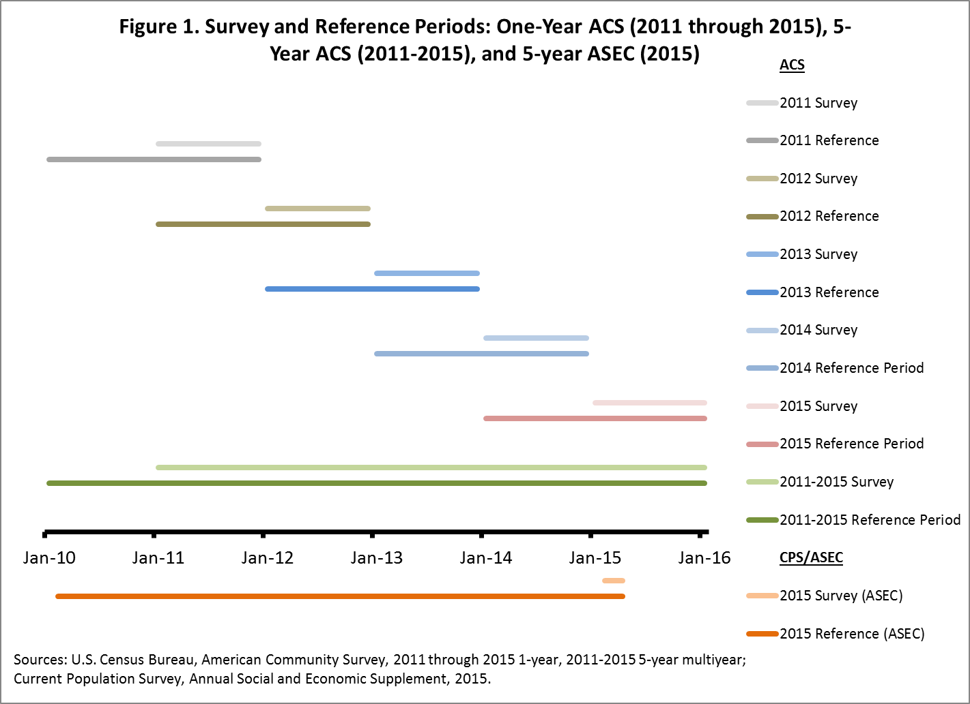

Table 1. Hypothetical Mover Rates by Year
Migration Data | Year 1 | Year 2 | Year 3 | Year 4 | Year 5 | Five-Year Multiyear Estimate | Five-Year Estimate
ACS 1-year | 15 | 15 | 20 | 18 | 15 | - | -
ACS 5-year | - | - | - | - | - | 16.6 | -
ASEC 1-year | 12 | 12 | 16 | 14 | 12 | - | -
ASEC 5-year | - | - | - | - | - | - | 33
Sources: U.S. Census Bureau, American Community Survey, Current Population Survey, Annual Social and Economic Supplement.

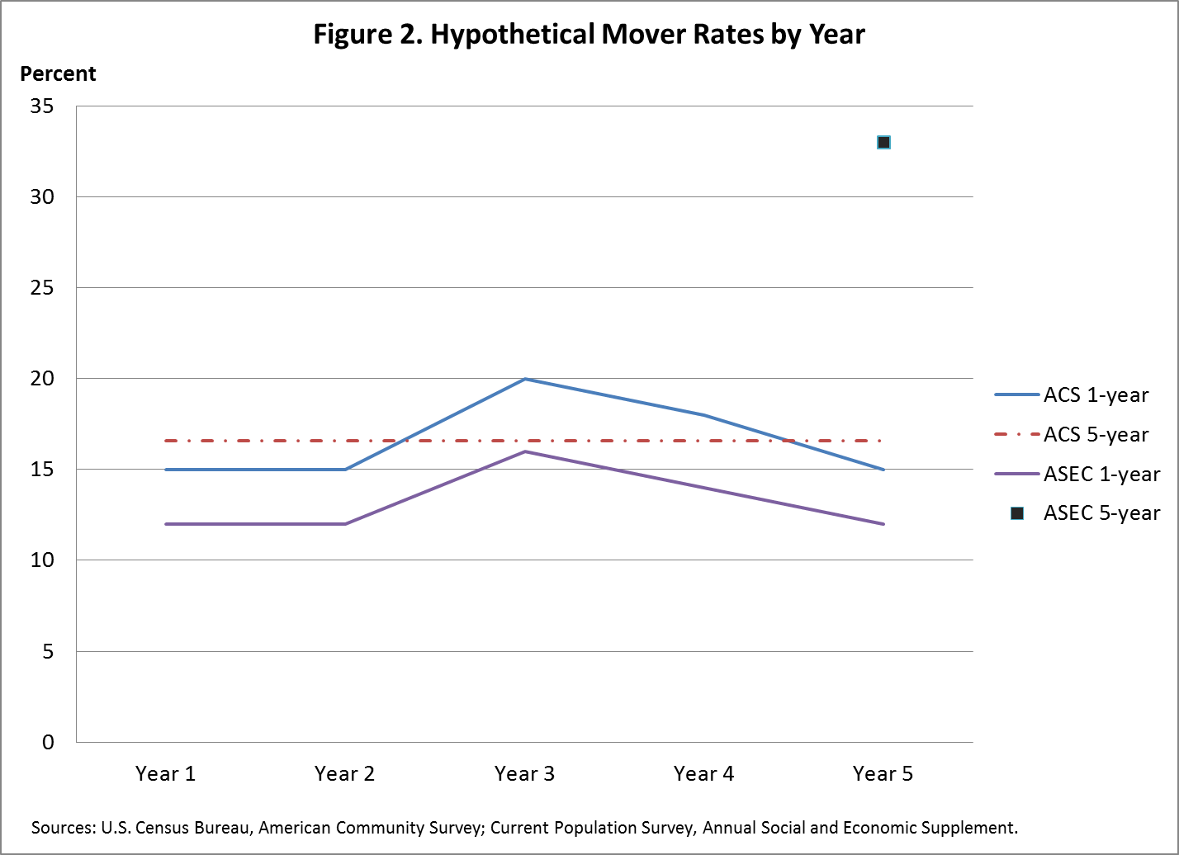

This paper reports the results of research and analysis undertaken by U.S. Census Bureau staff. It has undergone more limited review than official publications and is released to inform interested parties of ongoing research and to encourage discussion of work in progress. Any views expressed are those of the author and not necessarily those of the U.S. Census Bureau.
Comparable meaning they ask similar one-year migration questions and produce similar one-year migration estimates.
For a general overview of why the rates differ, see the “Comparison of Migration Data: 2013 American Community Survey and 2013 Annual Social and Economic Supplement of the Current Population Survey” working paper, available at http://www.census.gov/library/working-papers/2015/demo/SEHSD-WP2015-21.html.
The March Supplement of the CPS changed its name to the Annual Social and Economic Supplement (ASEC) after the State Children’s Health Insurance Program (SCHIP) expanded the survey months to include February and April around 2002. For more information, see the 2015 ASEC technical documentation, available at http://www2.census.gov/programs-surveys/cps/techdocs/cpsmar15.pdf.
For more information on the test and design phases, see Chapter 2 of the Design and Methodology Report, available at http://www.census.gov/programs-surveys/acs/methodology/design-and-methodology.html.
Additional information regarding single-year and multiyear estimates is available in the document “What General Data Users Need to Know,” available at http://www.census.gov/content/dam/Census/library/publications/2008/acs/ACSGeneralHandbook.pdf.
The creation of the multiyear datasets involves updating the vintage of geography to the current year, bridging migration geographies to the current year, and updating or crosswalking other variables, such as inflation factors. Methodological changes and improvements are also incorporated. More information about multiyear processing is available in chapter 10 of the Design and Metholodogy report, available at http://www.census.gov/programs-surveys/acs/methodology/design-and-methodology.html.
The 1-year and 5-year estimates for the percent who moved within the same county were not significantly different.
The population universe for the ACS migration question was the population 1 year and over.
For additional information, see the appendix of the report “Geographical Mobility: 2005 to 2010,” available at http://www.census.gov/content/dam/Census/library/publications/2012/demo/p20-567.pdf.
Because this scenario is hypothetical and for demonstration purposes only, no reprocessing was conducted.
12-month period can be used interchangeably with 1-year period.
As a reminder, ASEC is a supplement of the CPS. ASEC was previously referred to as the March Supplement before 1998.
Members of the armed forces who live on post with their families, armed forces members who live off post, and college students who live outside of college dormitories are included in the CPS/ASEC population universe.
ACS migration flow products are available at http://www.census.gov/topics/population/migration/guidance.html. The Census Flows Mapper, a tool designed to visually map county-to-county migration using 5-year multiyear ACS data, is available at http://flowsmapper.geo.census.gov/.
For more information, see “Comparing ACS data” at https://www.census.gov/programs-surveys/acs/guidance/comparing-acs-data.html.

